UX1CP - the famous pre-war polar radio operator
George Chliyants (UY5XE)
Oleg Kuksin (04.26.1912—08.07.1984) lived in Leningrad and was a famous polar radio operator who took part in many complex polar expeditions and operations.
After graduating from the technical school and passing the state exam for the title of ship radio operator in 1932, he joined the Morflot and was appointed senior radio operator for the Arctic icebreaker "Fedor Litke". In 1933-1934 "Fedor Litke" made an accident-free march along the Northern Sea Route for one navigation from Vladivostok to Murmansk and Leningrad (“Northeastern expedition”), which lasted 83 days. In 1933, while on this hike, “Fedor Litke,” he was sent to rescue the Chelyuskin steamer sunken in the ice (his radio operator was Ernst Krenkel, who at that time had the call sign U3AA, later - RAEM).
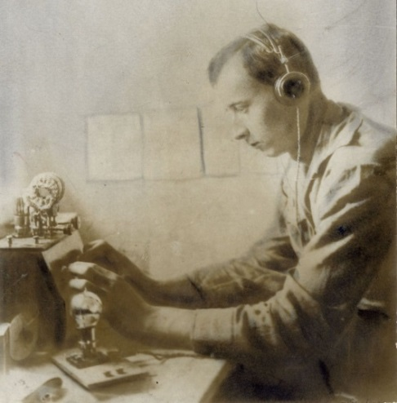 1934
In 1934 he received his first government award - the orden “Red Banner of Labor”.
Since 1935, his goes to the Baltic Shipping Company and works on the steamers “Vetluga”,” Berezina” and “Vanzetti”. In 1937, a new stage of its life begins - work in the system of the Directorate of Polar Aviation of Glavsevmorput. In August 1937, Oleg Kuksin participated in an air expedition in search of S. Levanevsky who had disappeared on August 13 as a flight attendant on an “H-172” airplane October 15, 1937 Nikolai Stromilov (U1CR) flew away from Oleg Kuksin (U1CP) took Rudolph I. (F.J.L.) to at home and his place in the radio room of the polar station, continuing to maintain regular professional communication with the radio station of the “NP” expedition with the call sign UPOL (until the end of the expedition). Note. Nikolai Stromilov (1909-1980): 1927-28 – 36RW, 1928-33 – eu3BN, 1933-41 – U1CR, after WWII – UA3BN. Since 1939, Oleg Kuksin worked at the Moscow Special Purpose Group of the Polar Aviation Administration. From March 1939 to March 1940, U1CP was on Rudolph I. as a flight attendant of the “H-171” aircraft, who was based on the island in order to ensure the safety of the drift of the “Sedov” icebreaker steamer (the drift duration is from 20.03.1939 to 13.01.1940).
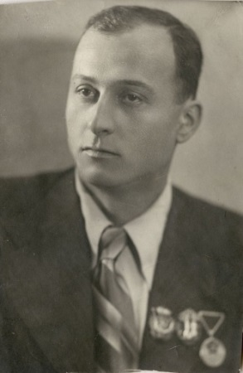 1940
All this time UX1CP regularly sounded on amateur bands.
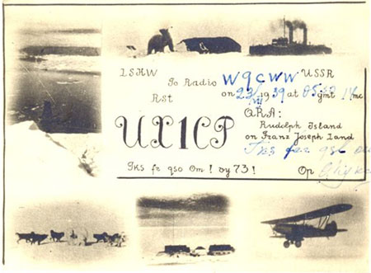
Note. The letter "X" in the call sign meant an "experimental" radio station. In the future, as a radio operator, O. Kuksin participated in all high-latitude expeditions INorth", in flights and special missions, ice reconnaissance in the Arctic and Antarctic (!2nd Antarctic Expedition”). In 1941, Oleg Kuksin made the first flight to the USA (to Seattle, through Alaska) as part of the aircraft's crew of V.Zadkov. During the war, O. Kuksin participated in the implementation of special tasks for the delivery of ammunition, ice reconnaissance, the escort of transport and military ships on the Northern Sea Route, the transfer of ammunition to the Leningrad region. After the war, he took part in the high-latitude expeditions "North-2" and "North-4". In the spring of 1949, he participated in the landing of groups of scientists in thirty points of the Arctic, which greatly contributed to the research of the North Pole, the Beaufort Sea, and the sea spaces in the region of Alaska, Canada and Greenland. For his many years of flight work in the development and study of the Arctic, for his courage and labor prowess during the fulfillment of special tasks of the Government at the North Pole, O. Kuksin was awarded the title “Hero of Socialist Labor” in 1949. From December 1956 to January 1957, the Second Antarctic Scientific Expedition of the USSR was held, as a result of which two more inland stations “Vostok” and “Komsomolskaya” were established in Antarctica. O. Kuksin took part in it - was a flight attendant in the crew of the squadron commander A. Moskalenko. In total, he flew more than 3 million km, including flights to the Arctic, and spent more than 12 thousand hours in the air. At the end of 1960, due to the state of health of Oleg Kuksin, they were removed from their flight work and were transferred as a special equipment engineer to the Training Unit of the UPA GVF.
The last ten years of his life, O. Kuksin lived in Moscow and passed on his experience and knowledge in the Polar Courses of the General Directorate of Hydrometeorological Service to the younger generation, coming from the North to study radio and meteorology.
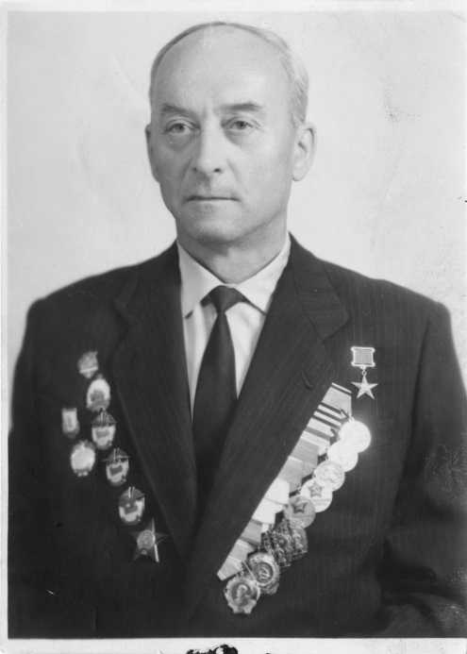 1980

